**Why leading organisations are investing in mindfulness**

**Paul Bibby**

It’s a busy Monday morning in the New York offices of Goldman Sachs.

Dozens of staff are at their desks powering through emails, and numerous planning meetings are in full swing.

But down the corridor in the accounts department something different is happening.

The team is sitting in a circle – completely silent; eyes closed; meditating.

A facilitator guides the participants through a body scan meditation designed to cultivate easeful, present-moment attention that in turn helps to regulate stress and improve focus.

A few minutes later a chime sounds, the participants take a deep breath, and go back to their work stations.

Welcome to the world of corporate mindfulness.



Once regarded as the domain of “monks and hippies”, mindfulness training is now being implemented in thousands of workplaces across the globe as senior managers and CEOs recognise the benefits for both productivity and staff wellbeing.

A survey of 163 companies conducted by the National Business Group on Health in 2018 found that 52 per cent of respondents offered workplace mindfulness training [1].

The large and growing list of companies providing mindfulness education to their employees includes household names like Goldman Sachs, Intel and Nike, as well as the famously progressive staff-focused folk at Google.

The level of training offered ranges from semi-regular one-off training sessions, to approaches which seek to embed mindfulness into the fabric of organisational life.

For example, at global food manufacturer General Mills (think Yoplait, Old El Paso and Häagren Dazs) mindfulness education has become an integral part of the company’s mission to create a healthy work environment and culture.

There is a meditation room on-site, monthly lunchtime lectures, and the company declares that each employee is now, effectively, his or her own “meditation instructor”.

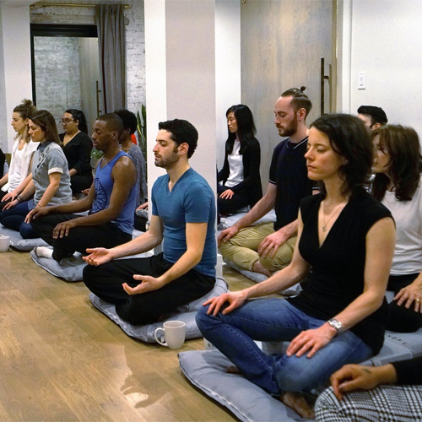

Another example is computer giant Intel, which has a company-wide employee wellness policy in which mindfulness training features prominently. This includes an expertly-facilitated mindfulness program called Awake@Intel, and allocated time for meditation.

Participants in the program reported that they were more focused and creative, were able to cope better with work-related stress, and felt more connected to their colleagues.

These types of benefits, both on an individual and organisational level are among the key factors driving interest in corporate mindfulness in recent years.

They are reinforced, not only by the experience of companies that have introduced mindfulness training, but a growing body of research into the application of mindfulness in the workplace.

So, what exactly are the benefits of mindfulness education in the workplace that are attracting so many of the world’s leading organisations?

**Performance**

Well, for a start, staff who develop a regular mindfulness practice exhibit tangible improvements in their ability to sustain a clear and stable focus on the task at hand, meaning they are less prone to mind wandering and less likely to get caught up in the multitude of distractions that characterise modern workplaces [2].

They are therefore less likely to make errors produced by lapses of attention, and to complete tasks quickly, efficiently and accurately.



Mindful employees have also been shown to be less impacted by emotional stressors in the workplace, from garden variety challenges like disagreements between colleagues, to the major emotional impacts of the global pandemic.

This is because a core skill of mindfulness is the ability to recognise when a challenging emotion arises and respond in a helpful way rather than reacting in a habitual or “knee-jerk” fashion.

The benefits of this, not only in terms of individual performance, but also for a happy and collaborative workplace, have been a significant inducement for organisations to invest in corporate mindfulness training.

**Relationships**

Relationships with leaders and managers are among the most important relationships we have at work, and the ability to collaborate effectively with others often depends on effective cooperation and coordination between members [3].

The evidence suggests that mindfulness affects interpersonal behaviour and the quality of relationships through cultivating greater attention to others, improved listening skills, reduced conflict, reduced emotional reactivity and

greater compassion and empathy [3].



This includes the important role of mindful leadership.

Not only does this improve the performance of teams in the workplace, but it also contributes to a greater sense of enjoyment and a healthier workplace culture, both of which contribute significantly to staff wellbeing.

The recent pandemic has brought renewed focus on the importance of wellbeing in the workplace, particularly the debilitating impacts of stress and other mental and emotional health challenges.

**From Stress to Wellbeing**

Ongoing stress reduces the body’s physiological, attentional and emotional coping mechanisms, and reduces our ability to cope with future challenges [4].

Such chronic stress is a known contributor to clinical anxiety and depression, hypertension, poor immune function, and behavioural problems.

This directly impacts organisations through staff disengagement, attentional deficits, absenteeism and working while unwell, and leads to role adjustments and workers’ compensation claims [5].

A growing awareness of these impacts, along with a desire to support employee wellbeing, are driving a rise in the uptake of work-based stress-management interventions such as mindfulness.



Mindfulness is associated with a number of mechanisms involved in stress reduction, including a reduction in cortisol levels in response to threats, and faster recovery to baseline levels after a stressful incident occurs. These effects have, in turn, been linked to outcomes that include improved sleep.

These have flow-on effects for employee and organisational performance in terms of the physical and psychological health, reduced absenteeism and turnover, reduced burnout, and improved in-role performance.’

Far from being an alternative lifestyle choice favoured my monks and hippies, mindfulness education is fast becoming an evidence-based staple of progressive, engaged organisations across the globe.

***Paul Bibby****is a highly experienced and qualified Mindfulness Trainer and Coach. He has completed multiple mindfulness teaching certifications and has helped hundreds of people across the world bring greater calm, focus, clarity, and resilience into their lives. He has worked with multiple businesses and organisations to help bring the benefits of mindfulness into the workplace and is passionate about combining work and wellbeing. Contact: PaulEBibby@gmail.com*

References

1. <https://www.businessgrouphealth.org/en/resources/13th-annual-health-and-well-being-survey>
2. [Contemplating Mindfulness at Work: An Integrative Review'](https://static1.squarespace.com/static/5c99116eb2cf799e7983995f/t/5d8902d68b3a9b5b8c874ff3/1569260247405/Mindfulness+Integrative+Review+Lyddy+and+Good.pdf)
3. [A Systematic Review and Meta-Analysis of Workplace Mindfulness Training Randomized Controlled Trials.](https://eprints.utas.edu.au/29794/1/OCP-2017-0855%20BARTLETT%20et%20al%20Accepted%20Manuscript.pdf)
4. Burton, W. N., Chen, C.-Y., Schultz, A. B., & Li, X. (2017). Association Between Employee Sleep With Workplace Health and Economic Outcomes. *Journal of Occupational and Environmental Medicine, 59*(2), 177-183. doi:10.1097/jom.0000000000000934
5. Dewa, C. S., McDaid, D., & Ettner, S. L. (2007). An international perspective on worker mental health problems: who bears the burden and how are costs addressed? *Canadian Journal of Psychiatry, 52*(6), 346. doi:10.1177/070674370705200603